|SFTP enable disable for azure storage|
Created by hamza:
Erste schritte:

- Automation konto zu erstellen[Gleich region als StorageKonto].

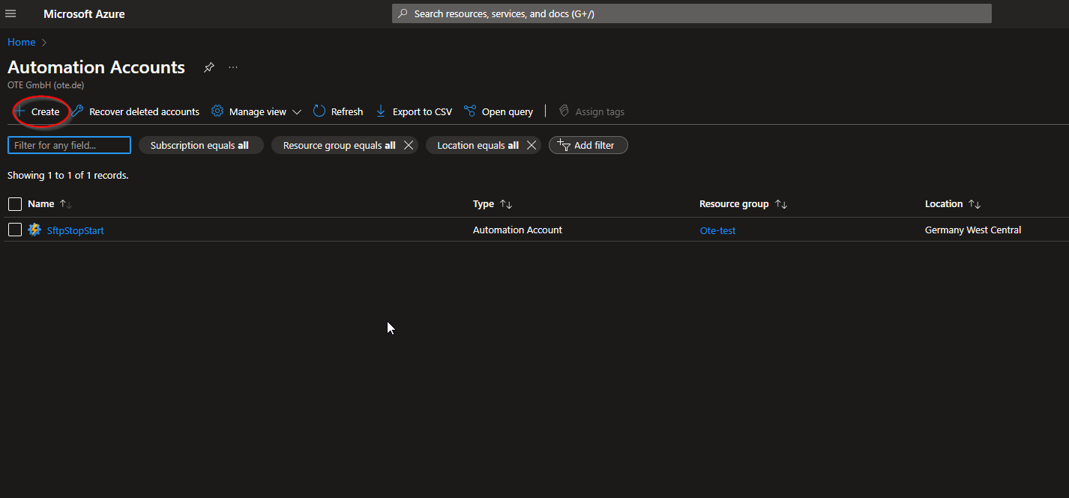

- After the creation of Automation accounts we going to create 2 scripts one turn on the Sftp the second turn off the Sftp
- Look for the runbooks case and click on it
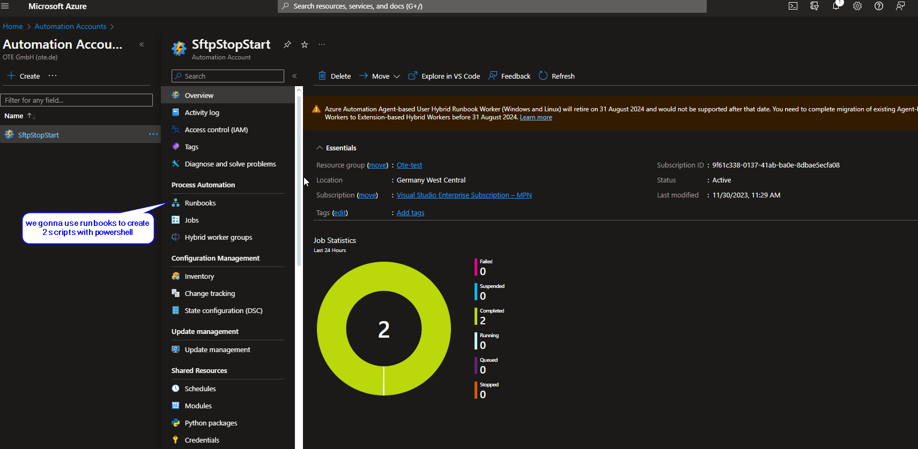

- Name the runbook
- Choose the development language
- Choose which version

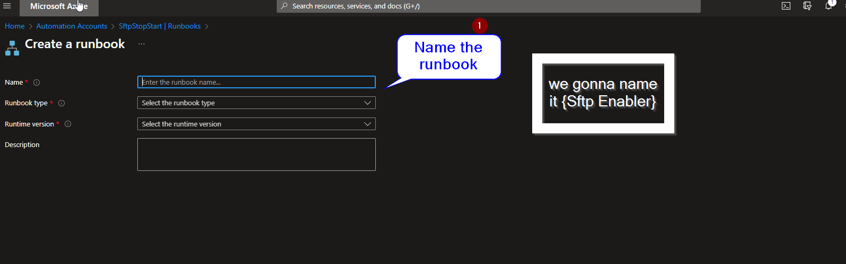

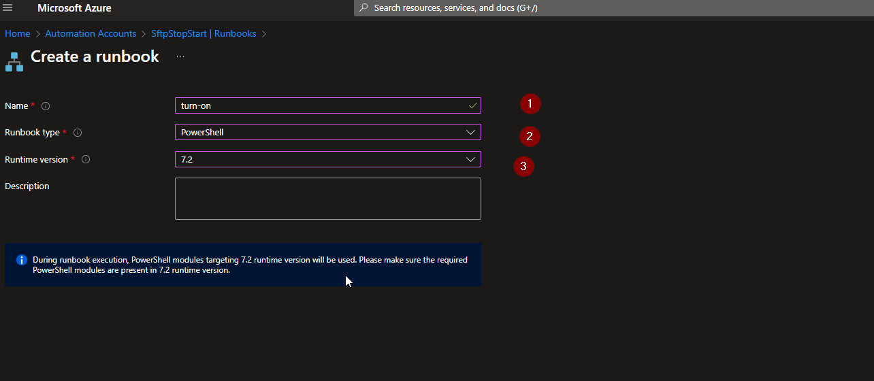

- After you click on create runbook it appears a development environment
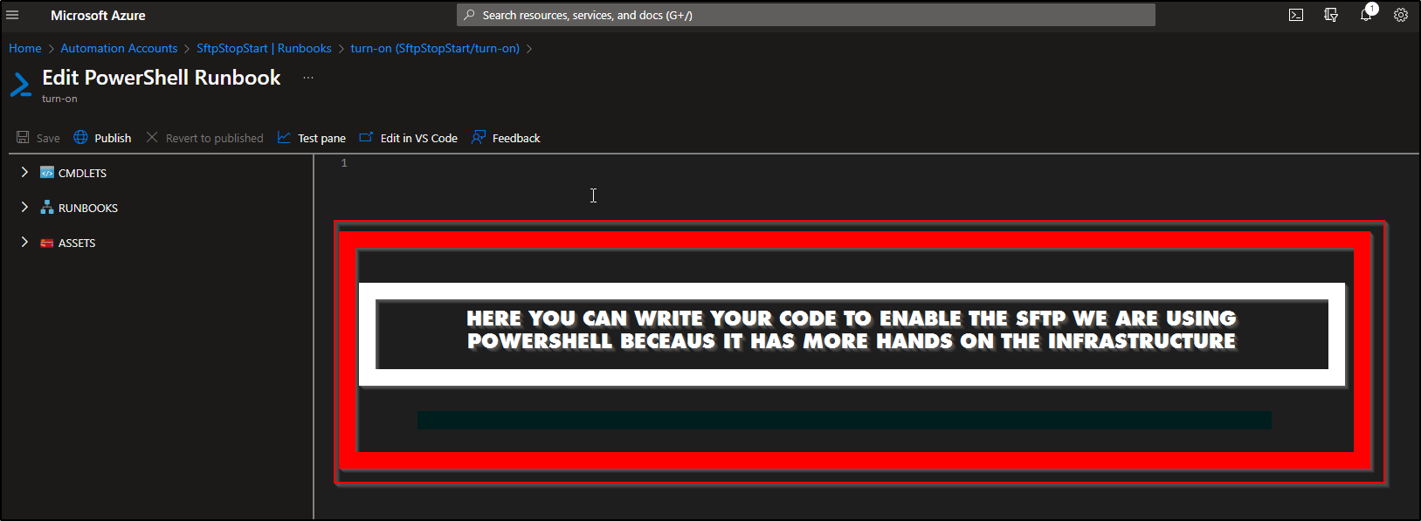
- The code to turn on the Sftp with exception if it s not in use:[suggested]
- Clean code [wroten by hamza]
- Easy to understand
- Can be modified and used

Paste it to the environment coding place

- # Activate SFTP Service automatically when someone wants to use it

- # Set the resource group and storage account name
- $resourceGroupName = ""
- $storageAccName = ""

- # Connect to Azure account
- Connect-AzAccount -Identity

- # Get the storage account
- $storageAccount = Get-AzStorageAccount -ResourceGroupName $resourceGroupName -Name $storageAccName

- # Check if SFTP is disabled
- if (-not $storageAccount.EnableSftp) {
- # SFTP is currently disabled, so turn it on
- $storageAccount | Set-AzStorageAccount -EnableSftp $true
- Write-Host "SFTP service activated for use."
- } else {
- Write-Host "SFTP service is already enabled."
- }

bumbum
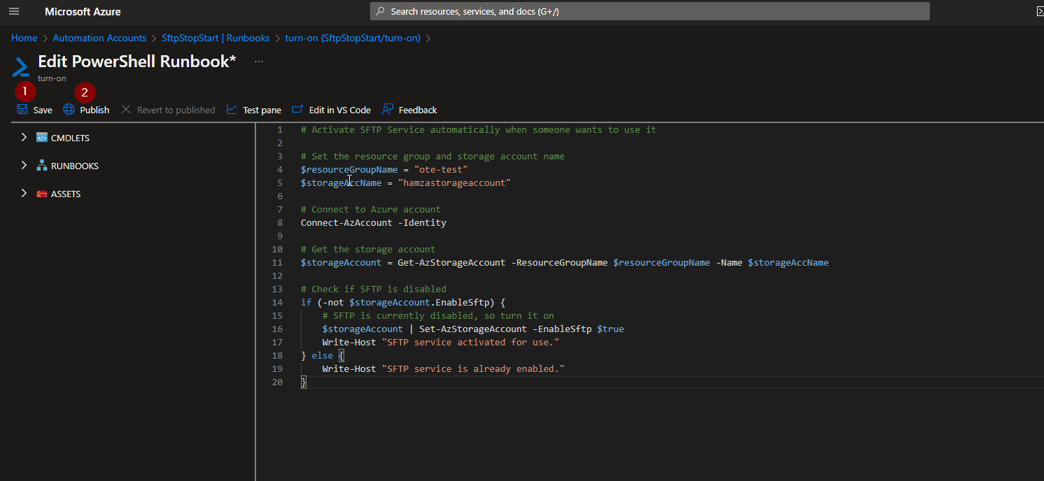

1.2 create a schedule for the script to be executed automatically everyday
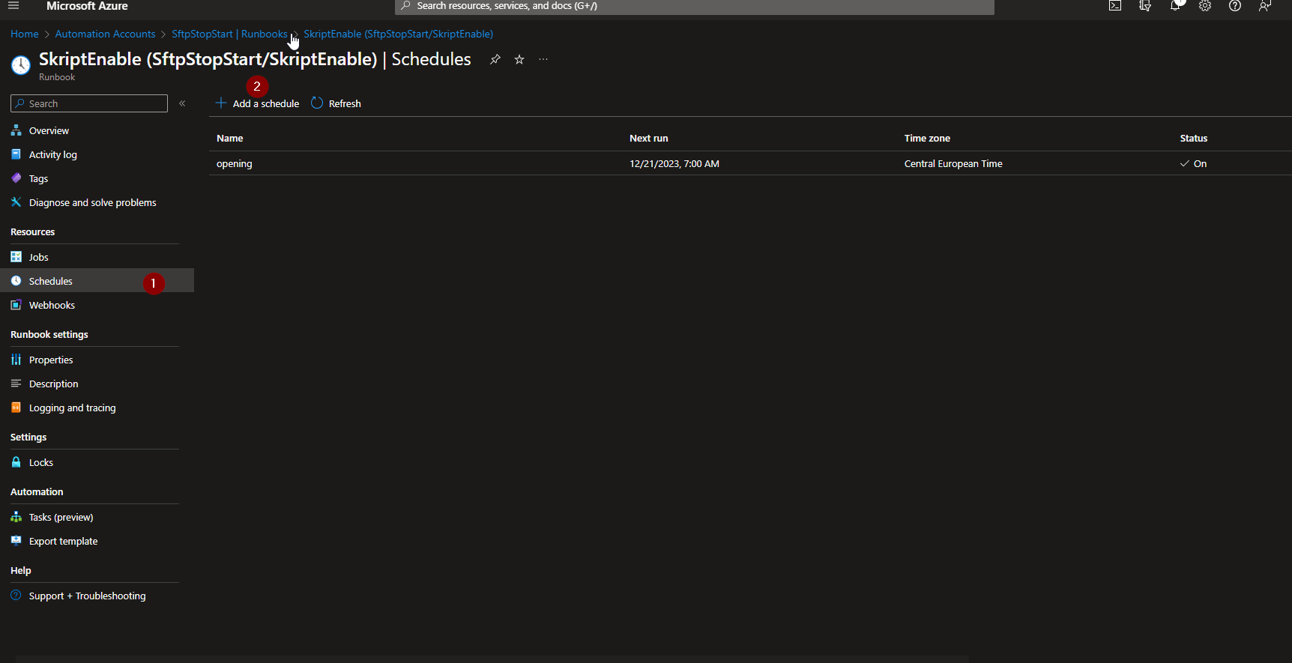

- LINK A SCHEDULE TO YOUR RUNBOOK
- ADD A SCHEDULE
- CREATE NAME
- WRITE DISCRIPTION
- MAKE TIMING WHEN TO BE EXECUTED
- DAY-HOUR-WEEK-MONTH
- SETT AN EXPIRATION DATE*

OUR OBJECTIVE IS TO RUN THE SCRIPT EVERYDAY ON THE WEEK FROM 6AM TO 19 PM UNTILL FRIDAY
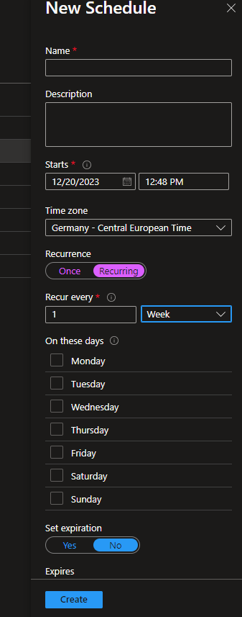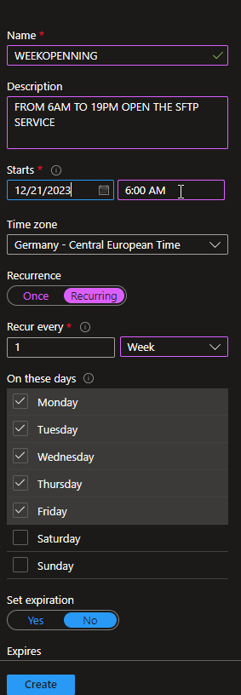

CREATE AND LINK IT
DONE
Part 2:
Create disabler of Sftp Service.
That disable the Sftp Service at 19PM
!!!!!!!!!!!!ACHTUNG!!!!!!!!!!!!!!!!
SAME ETAPES CHANGE JUST THE CODE AND SCHADUEL TIMING.

- CODE TO WRITE TO DISABLE SFTP SERVICE US

# Stop SFTP Service if not in use

# Set the resource group and storage account name
$resourceGroupName = ""
$storageAccName = ""

# Connect to Azure account
Connect-AzAccount -Identity

# Get the storage account
$storageAccount = Get-AzStorageAccount -ResourceGroupName $resourceGroupName -Name $storageAccName

# Check if SFTP is enabled
if ($storageAccount.EnableSftp) {
# SFTP is currently enabled, so turn it off
$storageAccount | Set-AzStorageAccount -EnableSftp $false
Write-Host "SFTP service turned off as it is not in use."
} else {
Write-Host "SFTP service is already disabled."
}

- SCHADUAL SET EVEYDAY AT 19PM UNTILL FRIDAY JUST SAME AS THE ENABLING SCHADUALING ONLY DIFFERENT WE ARE GOING TO CHANGE THE TIME
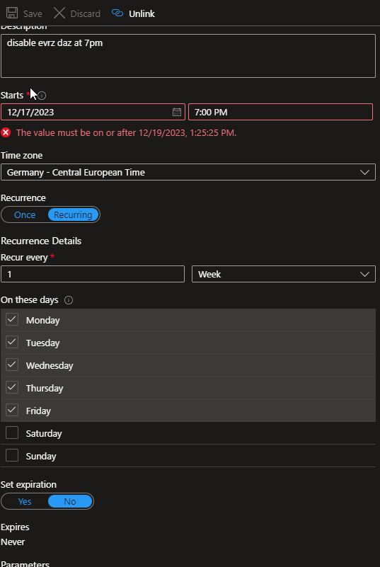

Documentation for errors could be appears from: MICROSOFT
DONE.

